**NoSQL-Mongo Lab4**

Use Robo 3 T to create the following:

1. Create new
   1. Database named **Demo**
   2. collections named t**rainningCenter1** , **trainningCenter2**

***NOTE: trainningCenter2 will apply all quires.***

1. Insert documents into **trainningCenter1** collection contains _id , name as firstName lastName , age , address as array , status

Using **Variable (Array Data)** and ***insert ONE***

1. Insert documents into **trainningCenter2** collection

Using Same **Variable (Array Data)** with same data and ***insert MANY***

1. Use find. explain function (find by age field) and mention scanning type
2. Create index on created collection named it “IX_age” on age field
3. Use find. explain view winning plan for index created (find by age field) and mention scanning type
4. Create index on created collection named it “compound” on firstNsme and lastName
   1. Try find().explain before create index and mention scanning type
   2. Try find().explain after create index and mention scanning type
5. Try to delete from your collection where _id = 5 [insert it if not exists]
6. Delete all documents from the trainingCenter collection.
7. Drop the database and confirm its removal. Which command do you use to ensure the deletion?
8. Backup your Labs database (**Mongo_ITI**)

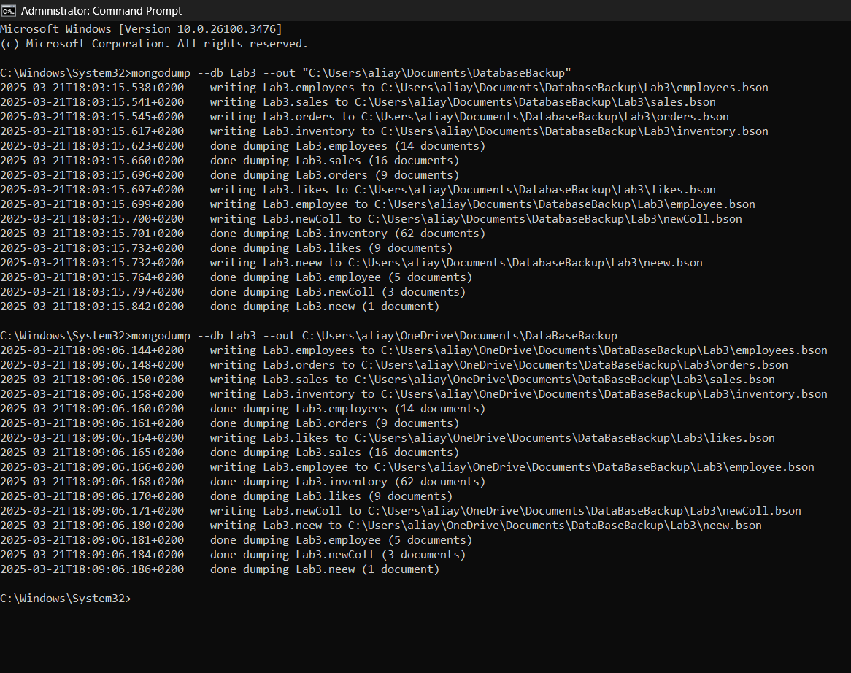

1. Restore the taken back-up by new DB name Called **Mongo_ITI_New**